- Aim: Root growth/Seed germination time-lapse imaging using SPIRO robot

**Experiment name**

Arabidopsis Seedlings growth time-lapse imaging using SPIRO robot.

**References**

<https://www.biorxiv.org/content/10.1101/2021.03.15.435343v3.full>

<https://github.com/AlyonaMinina/SPIRO.Hardware>

General overview: Ohlsson et al. 2021

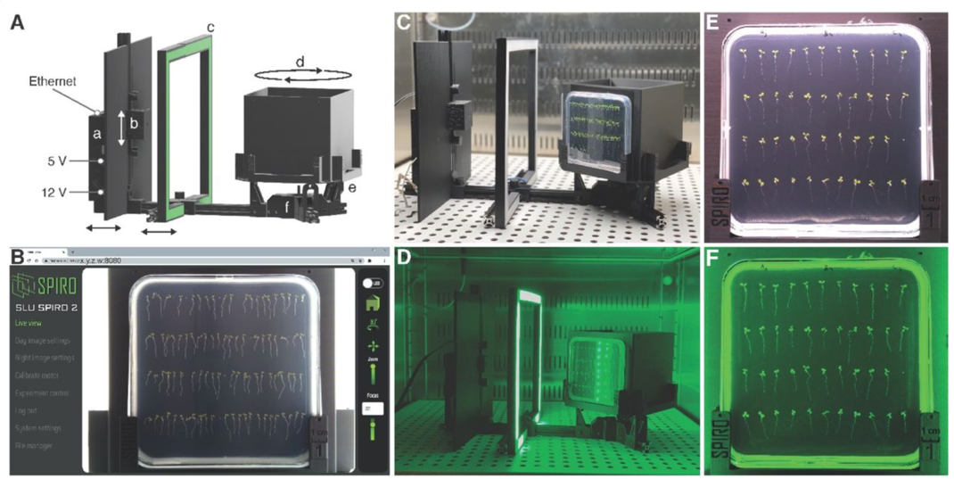

**Material and equipment**

* Square petri dishes
* MS solid medium
* Arabidopsis seeds/seedlings
* Spiro robot
* Tweezers

**Hardware**

-SPIRO robot located in Lemnagen growth chamber

- Vertical plate holder

- laptop with web browser

**Biological material**

-Arabidopsis seed/seedlings (agravitropic mutant can be used as control ie *pin2*)

**Other material**

* Gravitropism essay:
  1. MS/2, 10g/L sucrose, MES buffered medium (gravitropic essay) square plates to grow plants.
  2. 4 MS/10 -Sucrose MES buffered ph5.7 square plates to transfer plants and make imaging. Each plate should be filled with the same amount of medium (35ml).

**Time and technical constraint**

* Book both SPIRO using google calendar and Hood in the “salle de cribble”.
* Gravitropism essay:
  1. 45’ to transfer seedlings
  2. 1h for transfer recovery
  3. One day of imaging
  4. One day of analysis

**Precise description of the method**

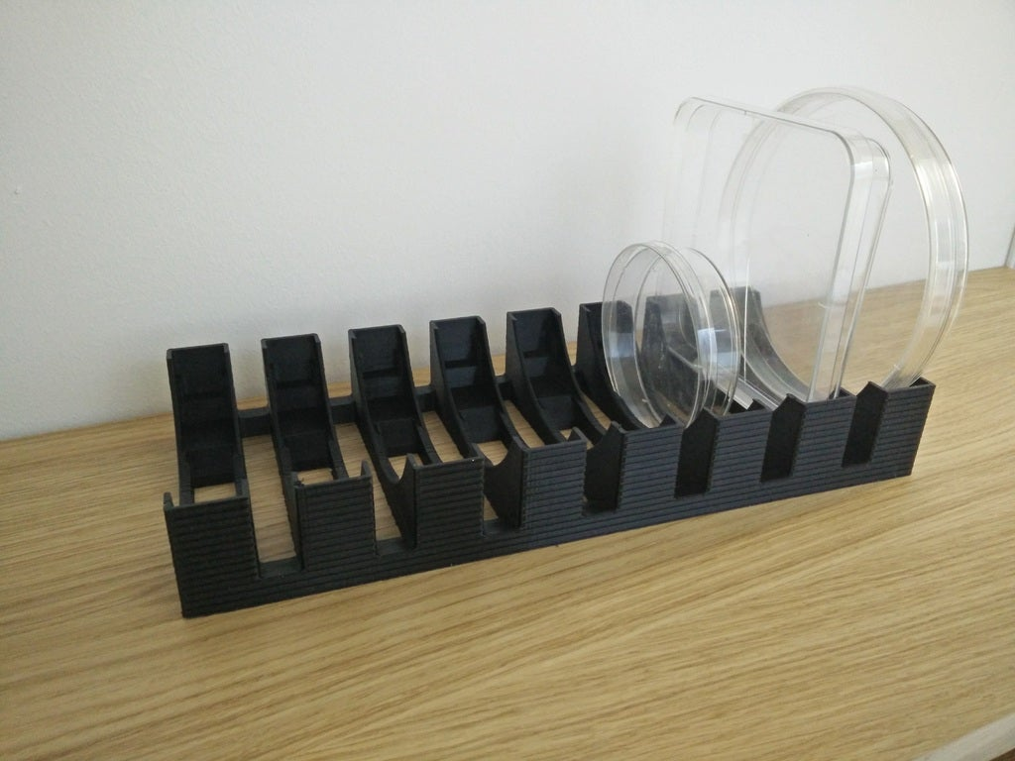

Vertical plate holder

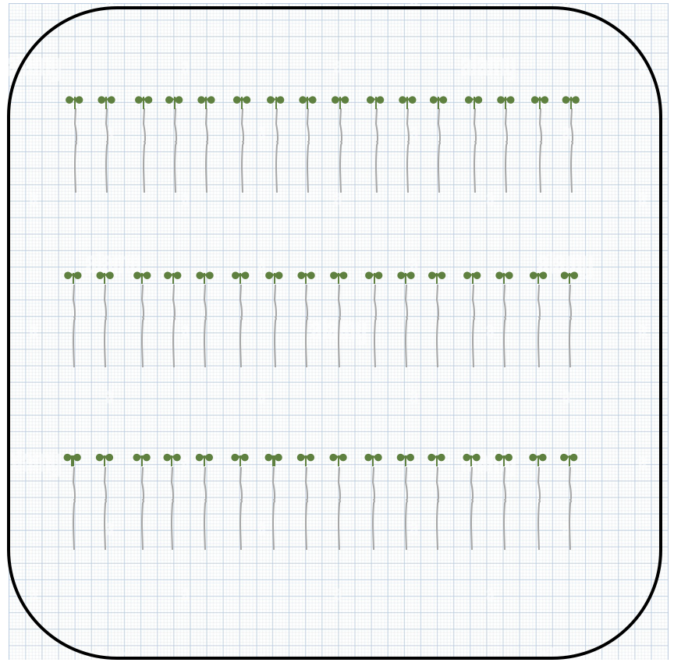

**Gravitropism essay:**

* **Plant transfer:**
  1. Sterilise tweezers (EtOH, Sterilizer dry beads…).
  2. Prepare grid paper, draw square plate contour and lines for plant transfer. 4-5 days old seedling can be transferred on 3 rows. However, if mutant roots are short, 7 days old growth seedlings would be needed for efficient imaging and then it should not be possible to make 3 rows of seedling for WT.
  3. Place the grid paper below the new petri dish.
  4. Take seedlings from growth plate and put primary root as straight as possible.
  5. For WT vs mutant, both can be placed in the same plate or one plate per genotype.
  6. Put the plates vertically on the vertical plate holder.
  7. Repeat step 4 until all the plants have been transferred to the 4 MS/10 plates.
  8. Plants have to recover for 1 hour before launching gravitropic stimulation
* **SPIRO setup:**
  1. Put the 4 plates in the SPIRO plate holder (Position 1-4), agar facing the camera.
  2. Turn the system ON by plugging the two power supplies (White corresponding to Raspberry computer and black to the motor).
  3. Connect to SPIRO wifi: spiro-949fe5 pwd: 2f115d30
  4. Connect to local user guide interface by pasting **spiro.local:8080/** in your web browser. pwd: SICEspiro .
  5. Details for SPIRO setup <https://github.com/jonasoh/spiro>. Normally Day and Night image settings should be the same between user and so not modified.
  6. User interface:

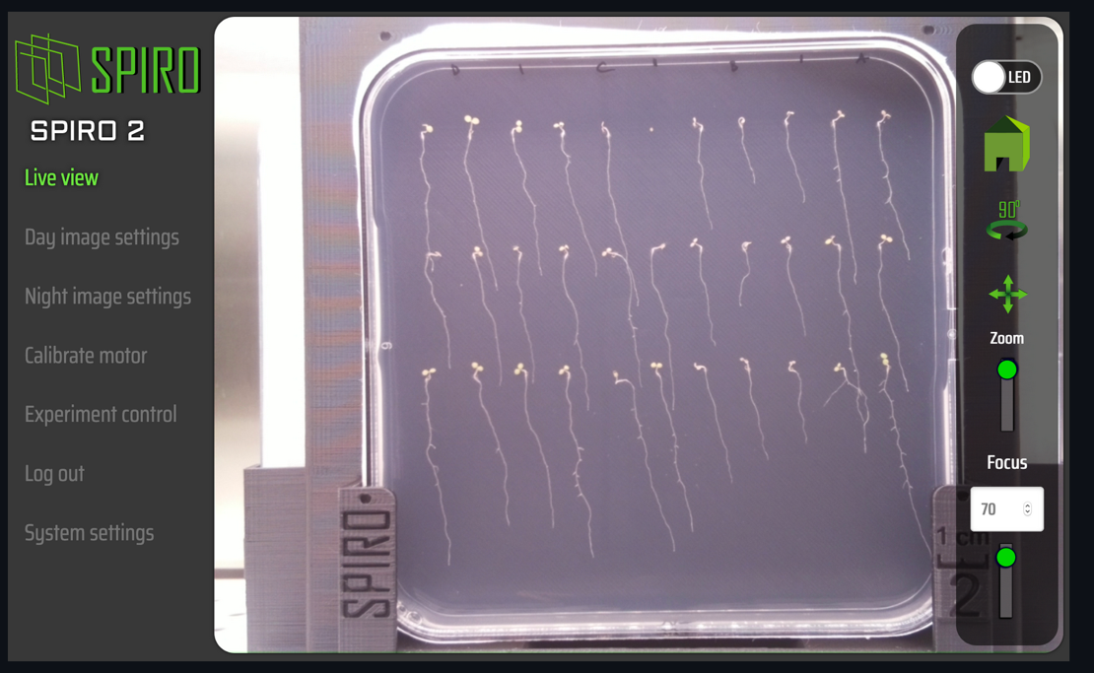

* 1. Click on the Green home button on the right to reach the 1st plate position. If the calibration is OK the plate should be in a perpendicular axis to the system facing the camera.
  2. Zoom to the center of the plate and adjust Focus to set up the focus on the roots. Zoom out
  3. Turn on the 90° button to switch to the next position and check that Focus is OK.
  4. Repeat step 9 three times until your reached back Position1.
  5. Click on Experiment setup

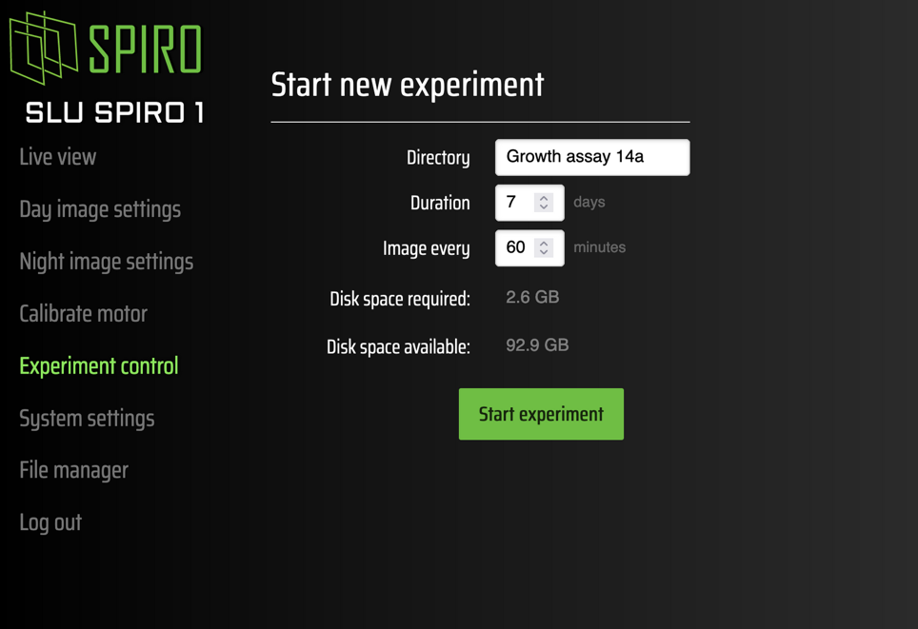

* 1. Let the Directory by default. Adjust the duration of the experiment, 1 day for example and Image every 15 minutes.
  2. One hour after the transfer, Turn your plates 90°.
  3. Click on Start Experiment
  4. Four pictures should appear then corresponding to the last timepoint taken for the four positions.
  5. You can cancel current experiment by clicking on Stop.
  6. To download files, go to file manager. You can either download or delete files.
  7. 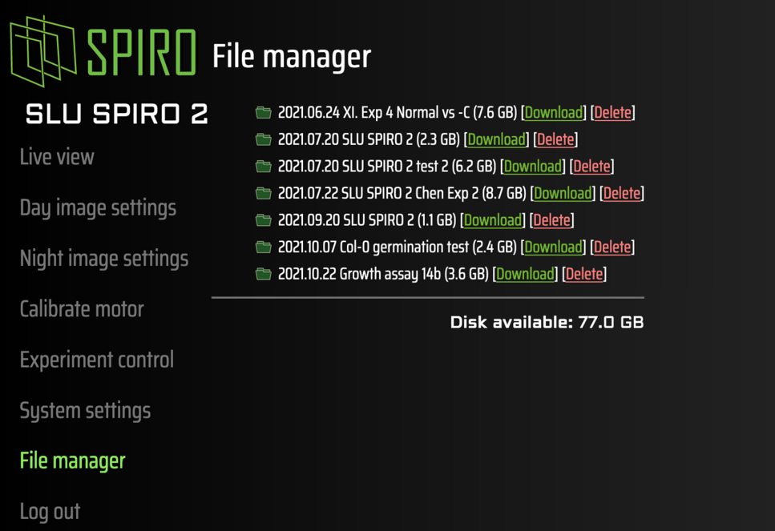
  8. To turn of the system, go to Systems settings
  9. 
  10. Click on Power off system.
  11. Once SPIRO wifi is no longer detected, you can unplug both power supplies.